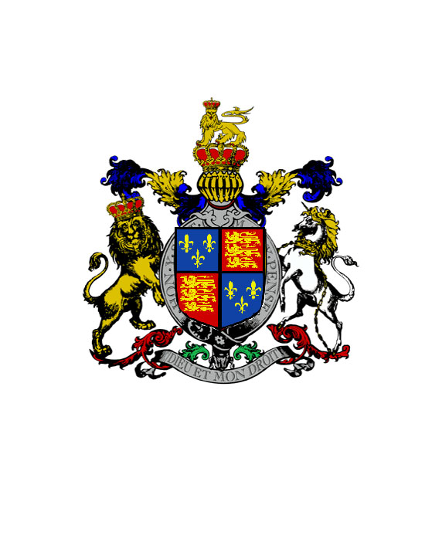
We Henry By The Grace of God of England, Ireland and France King, Defender of the Faith,

To All Who Shall Receive These Presents, Greeting

Whereas during the troubles of the last century the noble families of Howard and Wimsey were attaindered, and various of their titles, properties and offices forfeited, to such degree and for such duration as the King’s Pleasure disposed;

And Whereas the said noble families of Howard and Wimsey have rendered to the Realm and their Sovereign long and faithful service during Our present Reign, and have in all Things earned and deserved Our approbation and trust;

Now Therefore do We, of Our Sovereign Will and Pleasure, decree, announce, publish and proclaim by these Letters Patent:

That Our right trusty and faithful servant, the Noble and Gallant Lord, Edward Thomas Henry Mowbray Howard is vested with his ancestral title of Duke of Norfolk, Baron Beaumont, and Earl Marshal of England, in full Restoration of all the Titles, Privileges, Precedences, Lands, Properties and Offices pertaining thereto, and retroactive to the date of the Attainder and Forfeiture of the same, without Prejudice, Qualification or Reservation of any Kind or Degree; and

That Our right trusty and faithful servant, the Noble and Gallant Lord, Richard Peter Death Bredon Wimsey is vested with his ancestral title of Duke of Denver, Viscount St. George, and Master of the Horse, in full Restoration of all the Titles, Privileges, Precedences, Lands, Properties and Offices pertaining thereto, and retroactive to the date of the Attainder and Forfeiture of the same, without Prejudice, Qualification or Reservation of any Kind or Degree;

And We embrace These Noble Dukes with Our complete Love and Affection, and commend Them to Our Subjects.

Given at Our Palace and Seige Royal of Whitehall
1 February A. D. MDXXI

